**Opening a new vegan restaurant in Chicago**

Michael Basnar

February 2021

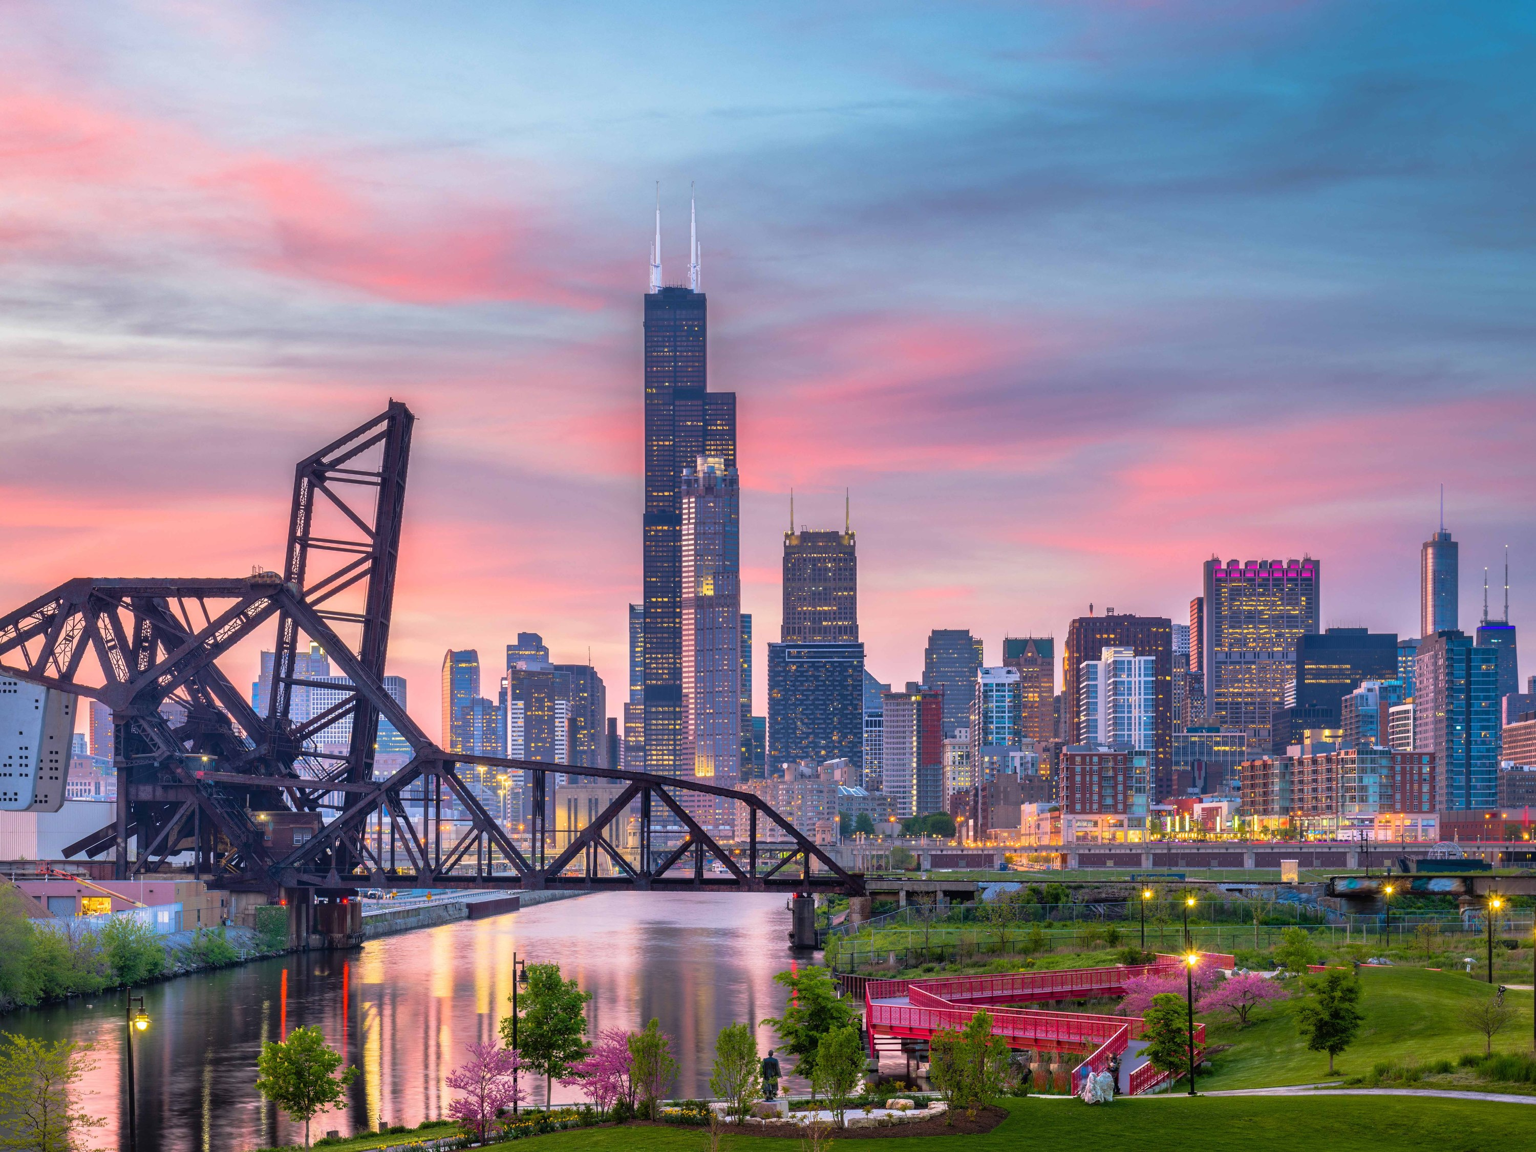

## Introduction/Business Problem

There has been a slow shift in interests to a vegan lifestyle in the Chicago area. In general the focus on being healthier has become of greater and greater concern. Even those who do not want to eat vegan 100% of the time have seen a need to eat healthier more often. The problem though is there seems to be a lack of vegan restaurants in the Chicago area. The potential to take advantage of this growing trend could prove to be quite profitable. Therefore to the right stakeholder it would prove beneficial to examine the city of Chicago's neighborhoods to ascertain the best possible locations for success and profitability. It is then the goal of this project to come up with the top 2 locations it seems likely a new vegan restaurant would succeed in Chicago.

## Data Process

The data acquisition of the data will come from the Foursquare database. It is currently the most reliant and up to date database for this type of project. The initial radius will be set to 1500 do to the fact lake Michigan covers a significant part of this radius. This may begin to include some of the suburbs but by doing so there is a hope it will deliver the best possible solutions for the stakeholders. In effort to do this the data we will be looking for will be focused on where there are current vegan restaurants since those are areas have already shown a demand for the cuisine.

Once the data has been acquired, the data will be cleaned and analyzed to reveal the best possible solutions based on the following criteria.

1. Vegan restaurants in the area

2. Ratings of vegan restaurants in each area

As the data process began it was very clear that there were very few vegan restaurants in Chicago. As the data was cleaned that number dropped even more to around 20. Initially it was hoped there were more but it did clearly present the evidence that there was a lack of vegan restaurants in Chicago.

Later in the process another issue popped up. There was absolutely no data on ratings. This was a disappointment since Foursquare is the largest and most reliable source of such data.

## Methodology

The methodology of the project will include the following processes.

1. Data acquisition from the Foursquare API

2. Data wrangling and cleaning

3. Data normalization if necessary

4. If necessary K-means clustering of the data to ascertain the areas that have vegan restaurants

5. Mapping and visualization of the data

6. Final analysis and conclusions

As the steps continued through the methodology it was clear that K-means clustering was not necessary. The reason for this was twofold. First there simply were too few data points to have any meaningful impact. Second, the mapped results made it plainly clear where vegan restaurants were in Chicago. This is presented below.

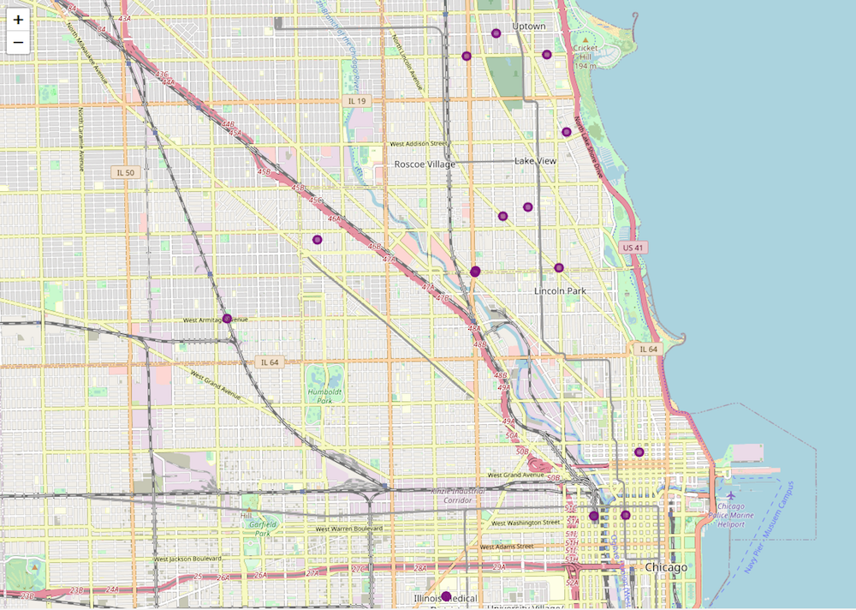

## Results

When looking at the final mapped results it is quite obvious to see where vegan restaurants are in Chicago. Three areas are clear. They are Uptown, Lincoln Park and downtown Chicago. Unfortunately it was hoped there would be a lot more data to help make a better determination. The goal was to identify 2 locations for a new restaurant. It would seem that the areas of either Uptown or Lincoln Park would be ideal as they both have the highest concentration. Further observations and recommendations will be in the following discussion section.

## Discussion

The results were less than what I set out to find. There is clearly a lack of vegan restaurants in Chicago. With the growing demand the areas of Uptown and Lincoln Park are the most concentrated and seem the most ideal. However, having personally knowing the city a bit there may be other areas to consider. Finding another source for data would be important. Unfortunately I do not know of another source of reliable data for this particular project. Some things to consider would be demographics or possibly foot traffic. The heart of the city known as the Loop has a good daytime population but in most of the areas vacates at night as an example. Discussing this with the stakeholder is therefore important to see if their needs are met within the scope of this project.

## Conclusion

The conclusion of this project that further research may be necessary in this particular case in order to determine the best spot for a new vegan restaurant. Although it is clear that if the stakeholder would like to make a decision based on this project's scope then they would certainly find success in either the Uptown and Lincoln Park areas of the city.